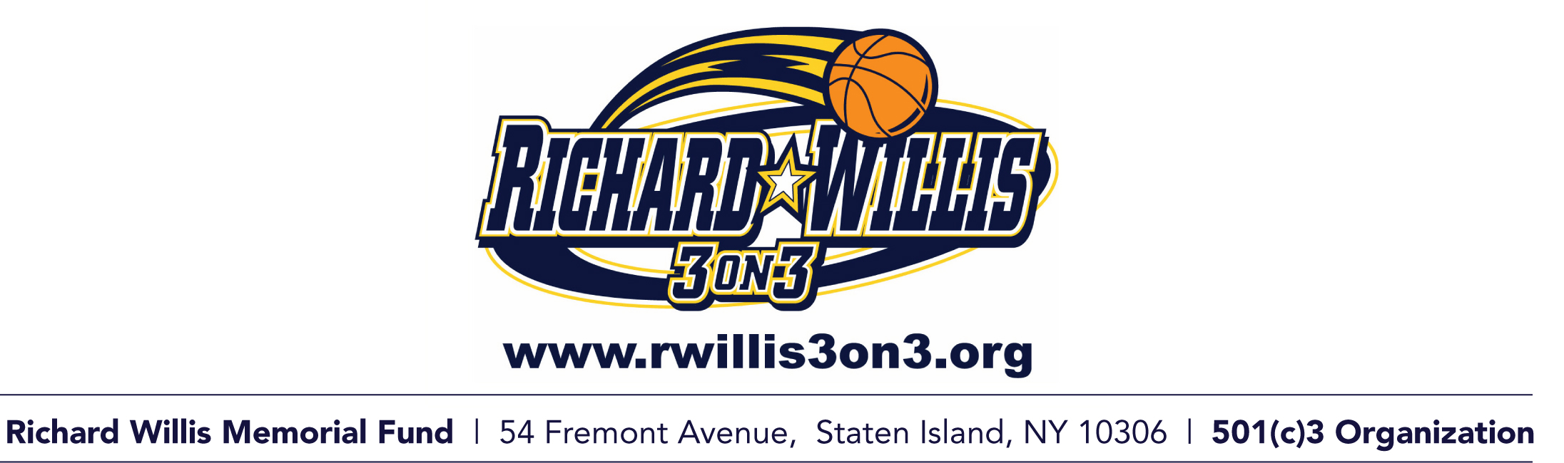
1. All teams are guaranteed 2 games. The tournament is double elimination.

2. First team after 30 points or leader after 15 minutes is the winner. All baskets are 2 points.
If a tie 3 minutes will be added to clock. Still first team to 30 points wins.

3. A coin toss by the court monitor before play begins determines which team will get possession of the ball. The ball will change possessions after a scored basket. The ball and body of the player must be taken back past the designated court line if the ball hits the rim or backboard.

4. There are no referees for 3 on 3 but the court monitor maintains control and protects the players.

5. All violations will be taken out of bounds at the top of the court past the designated court line.

6. The ball must be checked by the opposing player when inbounding the ball, regardless of time on clock.
7. There must always be a pass to begin the play. No Dribbling on inbound pass.

8. Jump ball goes to the defense. If defense can not be determined there will be coin toss.

9. All fouls must be called loudly and immediately by the player fouled. If a foul is not called or late called the game continues.

10. If fouled and basket made in the act the basket counts and the ball will change possession. If basket missed during foul call the player will retain possession of the ball.

11. Excessive fouling: This will be treated much like a technical foul. The team will be warned by the court monitor the first time. The next time(s) the team will be awarded the basket and the ball.

12. Excessive or unwarranted fouls calling: The court monitor will warn the team first. The next time the court monitor will award the other team the ball if they deem an unfair advantage is occurring

13. The player’s foul call is considered final. No appeals or discussion allowed.

14. Stalling or deliberate attempts to freeze the ball will result in loss of possession. The court monitor can issue a warning first. There must be an immediate attempt at a play for the basket.

15. Parents are asked to cheer their teams on. Coaching is not allowed.

16. Players will make all substitutions only after an injury or made basket. Players must notify the opposing team and Court Monitor.

17. Any unsportsmanlike like conduct, verbal abuse by players or their fans directed towards RWM court monitors, staff or opposing players will result in Team disqualification.

18. Flagrant Fouls: Any flagrant foul such as a push or hug of an opposing player, the basket will count for the offense and they will get the ball back. The next time that player will be seated for the rest of the game. If it happens again with the same player he will be asked to leave the 3 on 3. If it is deemed by court monitor that there was intent to harm another player that player will be ejected from the tournament. If there is another incident with the team the team is disqualified.

